“Provision not allowed outside grace period”? HERE IS THE SOLUTION

Are you having the following message come up every time you try and access a referral?
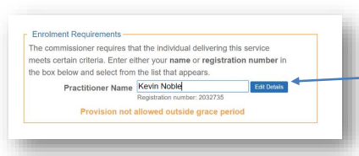
If a user is “Outside the grace period” they will no longer be allowed to process information until the nhs.net information has been entered into the system.

Follow these steps to resolve the problem:
- Click “Edit Details” button. This will take you to the enrolment page. The most common reason for the grace period error is due to an “organisational check”
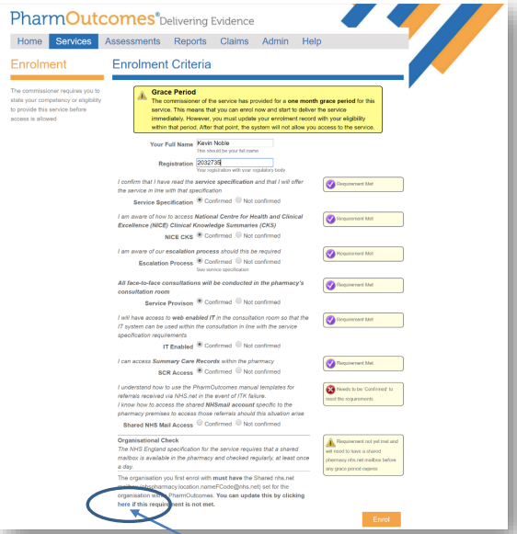
- Click the “here” button, as demonstrated in the image above.
- Update your secure NHSmail to the following format pharmacy.fcode@nhs.net e.g. pharmacy.FD763@nhs.net
- Click Save at the bottom of the page.
- This may bring you back to the homepage. To get back onto the enrolment page again click “edit details” as seen below

- On the enrolment page, scroll down to the bottom and then click the orange “Enrol” bottom of the page.
- Then refresh PharmOutcomes.
Any problems call Georgina Gillard on 07312276632

